Batch 2007-11    RAJENDRA AGRICULTURAL  UNIVERSITY, PUSA, BIHAR.  Contact no. 09576993009  email:  manoj20052007@gmail.com  manojraupusa@gmail.com  Correspondance Address:  Boy’s Hostel Room No 307  R.A.U, Pusa, Samastipur  Bihar, 848125  Permanent Address:  Personal Data:  s/o Sri Sipahi Singh  Vill Mathurapur  Post-Pakwalia  Dist- Siwan (Bihar)  Father’s Name :-  Shri Sipahi Singh  Gender: - Male.  D.O.B. :- 06-10-1988  Category :- OBC  Blood Group :- B^{+VE}  Nationality: - Indian.  Marital Status: - Unmarried.  Languages Known:  English & Hindi  Interests & Hobbies :  Playing game,Reading magazines and newspaper  Personal Skill:  - Co-operative, willing to share knowledge with team.  - Good in learning quickly. | manoj kumar singh  Student of B.Tech (Biotechnology)  Rajendra Agricultural University, PUSA.  CAREER Objective  Seeking Research training to utilize my skills and ability in a professional organization that offers professional growth. While being innovative and flexible.  Field of Interest  Research & Development, Bioinformatics  PROFESSIONAL QUALIFICATION  Pursuing 4 year full-time B.Tech (Biotechnology) programme from Faculty of Basic Sciences & Hummanities, Rajendra Agricultural University, PUSA, Bihar.  ACADEMIC QUALIFICATIONS  Outwards results are waited  eXTRA CURRICULAR ACTIVITIES  - Participate in National Symposium on Nanotechnology ,M.C.S, Patna- 2011.  - Participate in State Level workshop on Management and monitoring of field trial of Genetically Engineered Crops.  - Worked as volunteer in Disaster Management organized by Government of Bihar.2008  - Participate in training cum awareness programmed on protection of plant varieties and farmer Right (PPV & FR).  - National Seminar on applications of bio-technology & development of Bihar B.I.T patna 2010  TRAINING AND PROJECTS  - Summer training at Jain irrigation system ltd, Jalgaon Maharashtra 2010  - Workshop on Animal Experimentation & instrumentation M.C.S , patna 23 April 2010.  - Project training at National Agri-food Biotechnology Institute-Mohali 2011.  CAREER Objective   LANGUAGE – Basic C Language and Perl programing.   Fundamentals of Computer.   MS Office.   Operating System – Windows 98/2000/XP/VISTA  Seminar presented  - Transcription Mechanism  - Genetics of Immune System  - Bioprocess Engineering
  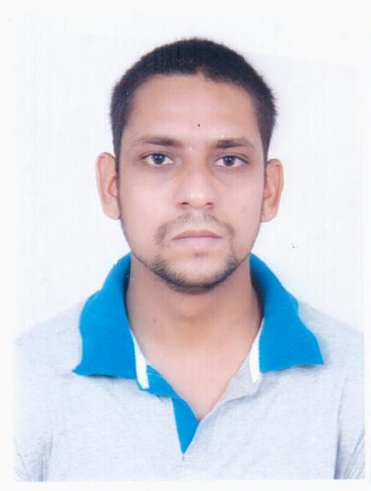
  EXAM | BOARD | YEAR | % MARKS
  10th | C.B.S.E | 2005 | 74.0
  12th | C.B.S.E | 2007 | 84.4
  SEMESTER | YEAR | % MARKS(GP)
  1 st | 2007-08 | 7.4
  2nd | 2008-08 | 7.5
  3rd | 2008-09 | 8.0
  4th | 2009-09 | 8.1
  5th | 2009-10 | 8.0
  6th | 2010-10 | 7.7

Declaration:
I hereby declare that the information furnished above is true to my knowledge and belief and i assure i will do the best for the upliftment of the company respecting all its rule and regulations.

Dated :
Place : Pusa 



